IECP Student Handbook

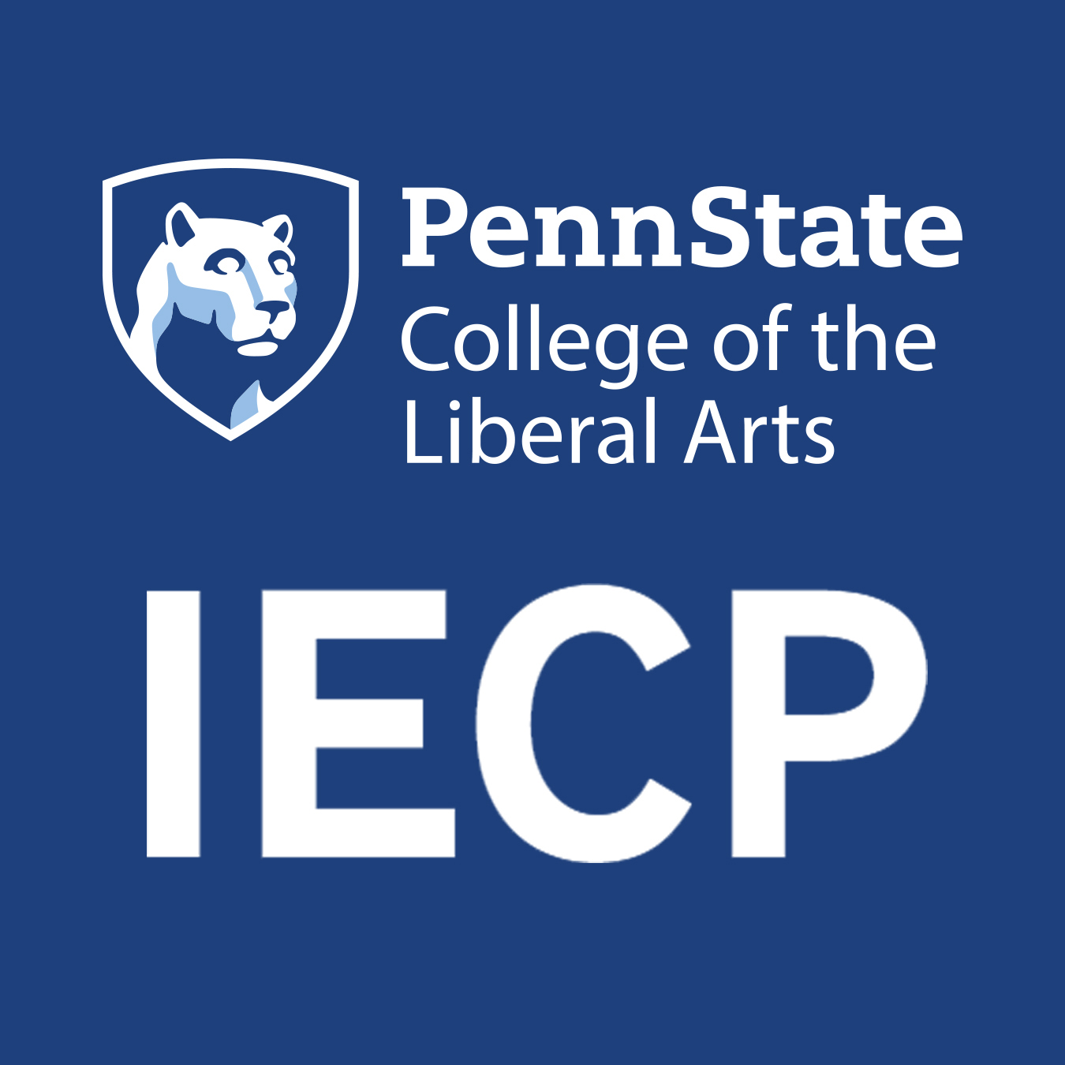

Intensive English Communication Program
FALL 2021

IECP Contact Information
Intensive English Communication Program Phone: 814-865-7550
The Pennsylvania State University Fax: 814-863-5889
112 W Foster Ave, 4th Floor
University Park PA 16802 USA

IECP Core Faculty and Administration:
Jason Litzenberg, Program Director and Student Advising (jjl53@psu.edu)
Nikki Mattson, Coordinator of Strategic Initiatives (nla12@psu.edu)
Tianyu (Ty) Liu, Assistant Teaching Professor (tul215@psu.edu)
Judy Maloney, Administrative Coordinator (jam52@psu.edu)

https://www.facebook.com/PennStateIECP/

https://twitter.com/pennstate_iecp

https://www.instagram.com/pennstate_iecp/

Important Phone Numbers
EMERGENCY 911
University Police 814-863-1111
DISSA Directorate of International Student & Scholar Advising 814-865-6348
UHS University Health Services Appointment Line 814-863-0774

IECP STUDENT HANDBOOK

Table of Contents
IECP Contact Information 2
Important Phone Numbers 2
Campus/Local Emergencies 5
Safety 5
IECP Mission Statement 5
IECP Student Responsibilities 5
Penn State Principles 6
U.S. Government Requirements 6
Policy for Time Off from IECP Study 7
Intent Forms 7
IECP Attendance Policy 7
Academic Information about the IECP 10
IECP Levels 10
Academic Interactions 11
Academic Literacies 12
Grammar & Speaking Skills 13
Grammar & Writing Skills 14
Upper Electives 15
IECP Class SAMPLE Schedule 16
Full-Time Regular IECP Students 16
Promotion to the next level 17
IECP Grading Scale 17
Final Grades 17
Academic Appeals 17
Sample grade report 18
TOEFL 18
Academic Honesty 19
Strategies and Behaviors for Success in the American Classroom 20
What Does a Successful Language Student Do? 20
Tips for Learning English 21
Strategies and Behaviors for Success 21
Penn State Computing 24
PSU EMAIL 24
ANGEL, CANVAS, SCHOOLOGY, BLOGs 24
CAMPUS COMPUTER LABS 24
PRINTING 24
IECP Student Center 24
Student Center Mission Statement 25
Student Center Services 25
Student Center Tutors 26
IECP Certification 26
What is Certification? 26
Certification application procedures 27
Pathways to Penn State (Dual-Enrollment) 27
Pathways to Penn State Procedures 27
IECP Policies 28
Complaints 28
Appeals 28
Probation, Academic Success Plan and Dismissal 29
Withdrawing from the IECP 30
IECP Refund Policy 30
Part-time Students 31
Textbooks 31
Making Copies 31
Sending Faxes 31
Letters of Recommendation 31
IECP Students Working 32
Continuing after program completion 32
Traveling in the U.S. 32
Advising 32
IECP Advising 32
Immigration Advising 33
Life at Penn State 33
IECP Activities 33
PSU Student organizations 34
Health Insurance & Medical Care 34
Health Insurance 34
Health Care 35
Serious Health Emergencies 35

The handbook contains important information about the program and its policies and procedures. You should read and keep this handbook with you for future reference. This handbook is also available on-line at http://iecp.la.psu.edu/

Campus/Local Emergencies
Campus Alerts:
PSUAlert is a service to receive Penn State news alerts through email, voicemail message and/or on your cell phone as SMS messages. IECP students are strongly encouraged to sign up:
https://psualert.psu.edu/psualert/
- Alerts can include messages about weather and campus closings. Serious emergency information is also on the university website, http://news.psu.edu, as well as on radio and television.

Safety
Compared to many places in the U.S., State College is a very safe place, but you should be careful anyway.
- Don’t carry large sums of money or valuables with you.
- Never leave your purse/book bag or other belongings unattended.
- Keep the door to your residence hall room or apartment locked when you are away.
- Don’t feel obligated to answer your residence hall or apartment door if you don’t know the person who is knocking.
- Don’t walk alone after dark, if possible, or certainly not after 10 p.m. If you must walk somewhere at night, call the PSU Escort Service at 865-9255 (865- WALK).
- Winter can be dangerous. Watch out for slippery sidewalks and steps. Cross streets with great caution—cars may have difficulty stopping on icy streets.

IECP Mission Statement

In teaching and service, the mission of the Intensive English Communication Program is to provide outstanding instruction in academic English communication to adult English language learners so that they can successfully participate in American institutions of higher education. The IECP is also committed to the continuous professional development of our faculty and staff and to contributing service and leadership to the TESOL profession through our faculty members’ teaching, service and committee work.

IECP Student Responsibilities
Students are responsible to do the following while they are enrolled in the IECP:
- Read the IECP Handbook carefully. Ask faculty or staff if you have questions
- Read and understand the syllabus for each IECP course
- Check your PSU email account every day
- Attend class regularly
- Arrive to class on time and return from breaks on time
- Study outside of class
- Do all homework and assignments and turn them in on time
- Be prepared for quizzes, tests, presentations, etc.
- Contribute positively to the work of the class
- Assume responsibility for any missed coursework and assignments
- Assume responsibility for your own learning. For example, ask instructors for help when you need it; learn from what other successful students do
- Always treat other students and faculty with respect
- Follow all IECP and Penn State rules and policies

Penn State Principles
- I will respect the dignity of all individuals within the Penn State community.
- I will practice academic integrity.
- I will demonstrate social and personal responsibility.
- I will be responsible for my own academic progress and agree to comply with all University policies. http://www.psu.edu/this-is-penn-state/penn-state-principles/

U.S. Government Requirements
- All F-1 and J-1 students must have valid, up to date, immigration documents and are required to study English full time.
- The U.S. government requires the IECP and Penn State to know your current address. If you move to a new address, you must report the new address within 10 days to the IECP and update it using iStart at: http://istart.gp.psu.edu.
- Please see your IECP Student Campus Guide for information on extending your I-20 or DS-2019, transferring to another university, requesting work authorization or travel signatures for traveling outside the U.S.
- Any questions about your visa, your I-20, your immigration status, or your SEVIS record should be answered only by DISSA (Directorate of International Students & Scholar Advising) at the University Office of Global Programs in Boucke building.
  - You can contact the IECP DISSA Advisor, Megan Lyang, at mzl141@psu.edu to arrange a remote meeting
Please note, many requests need to be made online through iStart at http://istart.gp.psu.edu

Policy for Time Off from IECP Study
The IECP expects that all students study continuously during the semester until they finish their IECP courses.
- The IECP follows Penn State’s holiday and break schedule. See
https://www.registrar.psu.edu/academic-calendars/2020-21.cfm
- Study during the summer semester is not required.
- Students who leave during the semester must withdraw from the program. See page 25 for the IECP Refund policy.

Intent Forms
At the end of each semester, students must indicate whether they plan to return the following semester or exit the program on the IECP Intent Form. It is the student’s responsibility to notify the IECP and to notify DISSA about their departure plans.
NOTE: IECP students are not required to study during the summer.

IECP Attendance Policy
Attending all of your classes every day is a very important obligation.

Absences limit a student’s language learning ability. Absences also have a negative impact on classmates and on instructor planning for the class session.

The IECP limit for absences is set high (See below), so there are no excused absences!

IECP students are responsible for understanding each of the following points of the IECP Attendance Policy:

How many times is a student permitted to be absent?
- For all students: you cannot miss more than 15% of the total class hours per semester. You must be in class 85% of the time.
- The IECP uses an “hour” system to calculate attendance, so if you miss one Academic Literacies class on a Monday, for example, you have missed a total of 1.2 hours. So, from the total permissible absences of 45, the student now has 43.8 absences remaining.
- Below is a table illustrating how many hours each class is and the total for each week. Part-time students should calculate this number depending on which classes they are taking.

Class | Number of classes x hours per week | Total hours per week
Academic Interactions (AI) | Two classes a week x 2 hrs each | 4hrs 0mins
Academic Literacies (AL) | Three classes a week x 1.2 hrs each | 4hrs 0mins
Grammar & Speaking Skills (GSS) | Two classes a week x 2 hrs each | 4hrs 0mins
Grammar & Writing Skills (GWS) | Three classes a week x 1.2hrs each | 4hrs 0mins
Special Topics | Two classes a week x 2 hrs each | 4hrs 0mins
Total hours for full-time students in the fall is 300.

How do I know what my attendance is?
- Students receive bi-weekly updates about their attendance by PSU email. Questions regarding the accuracy of your attendance records should be directed to your individual teachers and when necessary, to the Student Advisor.

Are there important limits to be aware of with attendance?
- Yes. Please see the table below

Full-time student: Fall 2021
1/2 absences | 3/4 absences |  | 100% absences
22 hours absents | 34 hours absent |  | 45 hours absent
Student receives attendance warning status | Student receives dismissal warning | Student is placed on Academic success plan | Student is dismissed from the program

What counts as an absence?
- If you miss more than 15 minutes of class: Arriving late, leaving early, leaving the class during class time, you are absent.
- The class hours are counted together, so if you miss one of the hours (eg, the first or second hour of the class), you are considered absent for the entire class.
- If you would like to speak with someone about your absences, please contact or visit the Program Director (jjl53@psu.edu, or in-person 112 W Foster Ave, 4th Floor).
- A returning student’s attendance is calculated from the first day of class for the semester. If the returning student arrives late for the semester, all classes missed count as absences.

What happens if a student is late (tardy) to class?
- All IECP classes begin promptly. Students arriving late or leaving class early are marked as tardy (Tardy 3 times = 1 absence).

What happens if a student exceeds the maximum number of absences?
- You may choose how to use your absences, but you CANNOT exceed the maximum number of absences. Full-time students who have exceeded the maximum number of absences are dismissed from the IECP. Their SEVIS record is then terminated immediately, and they must return to their country or transfer to another program within a limited amount of time. This policy applies to all students, including those who attain required TOEFL or IELTS scores and/or receive university admission during the semester. NOTE: If a student is dismissed from the program, no tuition is refunded.
- Students who withdraw from the program must do so in writing, and they do not receive final grade reports.
- Students who are facing program dismissal for absences are eligible to submit an appeal.

Do I receive any warnings about my absences?
- When a student meets or exceeds 50% of their permitted absences (for full-time students, 7 hours) they are placed on Attendance Warning status and they must meet with an IECP administrator. Notification of their attendance warning status is sent to their IECP instructors and to their government sponsors. Instructors also give students a letter in class regarding their absences.
- When a student meets or exceeds 85% of their absences, they are placed on Attendance Warning status, and they must meet with an IECP administrator. Notification of their attendance warning status is sent to their IECP instructors and to their government sponsors. Instructors also give students a letter in class regarding their absences.

What happens if a student misses assignments?
- One of the IECP Student Responsibilities states, "Assume responsibility for any missed coursework and assignments." An instructor's individual policy about missed work and assignments is stated on the course syllabus.
- Students should NOT expect an opportunity to complete assignments or complete assessments early in order to leave before the last day of classes. Absences at the end of the term may also affect grades on required assessments and the possibility of promotion/completion at the IECP.

Academic Information about the IECP

IECP Levels
- Level 100: Beginner
- Level 110: High Beginner
- Level 120: Intermediate
- Level 130: High Intermediate
- Level 140: AdvancedLevel Placement

The IECP is currently only running levels 130 and 140.

Students are placed into either 130 or 140 level courses based on the TOEFL, IELTS, or DuoLingo scores provided to the IECP upon application.

During the first week of classes, instructors give diagnostic tests and check students’ levels through different activities. They discuss any students who might be in a class that is too low or too high. This happens with very few students. However, if necessary, these students are moved to another class or level.

If you think you have not been assigned to the appropriate level for your English language ability, you may request a change by filling out the New Student Level Change Request Form. This form is available in the IECP office. You are required to include an explanation of your reason(s) for changing on the form. The form can be submitted no earlier than the second day of class. Submitting a form does NOT guarantee a level change; requests are reviewed by the Student Advisor and all faculty involved. Once a decision has been made, you are notified by email. Placement decisions are final and cannot be appealed.

We understand that many students come to Penn State with a deadline in mind for admission to the university and starting university courses. We also understand that students want to start their graduate or undergraduate studies as soon as possible. It is very important to understand, however, that students are never placed in levels based upon their timeline for university admission. We place them based on their ability in English as demonstrated on our placement tests for initial students and successful demonstration of promotion criteria for continuing students.

Academic Interactions
Ai 110— Academic Interactions 110 is a high-beginner course in academic oral communication. This course prepares individuals to comprehend and produce academic English for a variety of academic encounters. Students identify and begin to comprehend the content and communication strategies from lectures, academic discussions, and other academic interactions. With an emphasis on fluency, feedback on content, pronunciation and pragmatics is a fundamental component of the course, and opportunity is given for speaking practice in a variety of genres. By the end of the course, students will be able to:
- identify and begin to comprehend the content and function of academic talk at a high-beginner
level, including speaking strategies used in varied contexts. (Course Goal 1), and
produce speech and use speaking strategies at a high-beginner level to convey, describe, and
begin to explain information and ideas in varied academic contexts (Course Goal 2).
Ai 120— Academic Interactions 120 is an intermediate course in academic oral communication. This course prepares individuals to comprehend and produce academic English for a variety of academic encounters. Students identify and explain content and communication strategies from lectures, academic discussions, and other academic interactions. With an emphasis on fluency, feedback on content, pronunciation and pragmatics is a fundamental component of the course, and opportunity is given for speaking practice in a variety of genres. By the end of the course, students will be able to:
- identify and explain the content and function of academic talk at an intermediate level,
including speaking strategies used in varied contexts. (Course Goal 1), and
- produce speech and use speaking strategies at an intermediate level to convey, describe, and
explain information and ideas in varied academic contexts (Course Goal 2).
Ai 130—Academic Interactions 130 is a high-intermediate course in academic oral communication. This course prepares individuals to comprehend and produce academic English for a variety of academic encounters. Students comprehend and think critically about classroom lectures, academic discussions, and other listening and speaking interactions. With an emphasis on fluency, feedback on content, pronunciation and pragmatics is a fundamental component of the course, and opportunity is given for speaking practice in a variety of genres. By the end of the course, students will be able to:
- identify, comprehend, and think critically about the content and function of academic talk at a
high-intermediate level, including speaking strategies used in varied contexts. (Course Goal 1),
- produce speech and use speaking strategies at a high-intermediate level to convey, interpret,
and connect information and ideas in varied academic contexts (Course Goal 2).
Ai 140—Academic Interactions 140 is an advanced course in academic oral communication. This course prepares individuals to comprehend and produce academic English for a variety of academic encounters. Students comprehend and evaluate authentic classroom lectures, academic discussions, and other listening and speaking interactions. With an emphasis on fluency, feedback on content, pronunciation and pragmatics is a fundamental component of the course, and opportunity is given for speaking practice in a variety of genres. By the end of the course, students will be able to:
- identify, comprehend, and evaluate the content and function of academic talk at an advanced level,
including speaking strategies used in varied contexts (Course Goal 1), and
- produce speech and use speaking strategies at an advanced level to convey, evaluate, and
challenge ideas and concepts in varied academic contexts (Course Goal 2).

Academic Literacies
AL 110—Academic Literacies 110 is a high-beginner course in academic reading and writing. This course prepares individuals to comprehend and produce basic academic writing, with an emphasis on understanding and applying conventions in and across various academic genres. Students decode and study texts from academic textbook excerpts, newspapers, magazines, peer writing, and high-beginner ESL textbooks. With an emphasis on fluency, feedback on content, organization, and cohesion is a fundamental component of the course, and opportunity is given for reading and writing in a variety of genres. By the end of the course, students will be able to:
- comprehend the content and genre of high-beginner academic, utilizing basic lexical reading
strategies and an awareness of basic research conventions.
- develop sentences into paragraphs, utilizing literacy strategies at a high-beginner level to
convey, describe, and begin to explain ideas and concepts for academic writing tasks.
AL 120—Academic Literacies 120 is an intermediate course in academic reading, writing, and research. This course prepares individuals to comprehend and produce academic writing, with an emphasis on understanding and applying conventions in and across various academic genres. Students study and comprehend texts from academic textbook excerpts, newspapers, magazines, peer writing, and intermediate ESL textbooks. With an emphasis on fluency, feedback on content, organization, and cohesion is a fundamental component of the course, and opportunity is given for reading, writing, and incorporating sources in a variety of genres. By the end of the course, students will be able to:
- comprehend the content and genre of intermediate texts, utilizing intermediate
- lexical/semantic reading strategies and a basic understanding of research conventions.
- develop detailed, supported paragraphs, utilizing literacy strategies at an intermediate level to convey, describe, and explain ideas and concepts for academic writing tasks.
AL 130—Academic Literacies 130 is a high-intermediate course in academic reading, writing, and research. This course prepares individuals to comprehend and produce academic writing, with an emphasis on understanding and applying conventions in and across various academic genres. Students comprehend and think critically about authentic texts from scholarly article excerpts, newspapers, magazines, academic textbooks, and peer writing. With an emphasis on fluency, feedback on content, organization, cohesion, and audience awareness is a fundamental component of the course, and opportunity is given for reading, writing, and research in a variety of genres. By the end of the course, students will be able to:
- identify, comprehend, and think critically about the content and genre of high-intermediate texts, utilizing semantic/critical reading strategies and an understanding of research conventions.
- develop paragraphs into cohesive, source-responsible compositions, utilizing literacy strategies at a high-intermediate level to convey, interpret, and connect ideas and concepts for academic writing tasks.
AL 140—Academic Literacies 140 is an advanced course in academic reading, writing, and research. This course prepares individuals to comprehend and produce academic writing, with an emphasis on understanding and applying conventions in and across various academic disciplines. Students comprehend and evaluate authentic texts from common first and second-year Penn State course textbooks, academic articles, and peer writing. With an emphasis on fluency, feedback on content, organization, cohesion, and audience awareness is a fundamental component of the course, and opportunity is given for reading, writing, and research in a variety of genres and/or academic disciplines. By the end of the course, students will be able to:
- identify, comprehend, and evaluate the content and genre of advanced academic texts, utilizing
semantic/critical reading strategies and a highly-proficient understanding of research conventions.
- compose well-developed, cohesive, academically-sourced writings utilizing literacy strategies at an advanced level to convey, evaluate, and challenge ideas and concepts for academic writing tasks.

Grammar & Speaking Skills
GSS 110—Grammar & Speaking Skills 110 is a high-beginner course in speaking practice and oral grammatical accuracy. This course prepares students to comprehend, use, and revise grammatical structures in speaking, particularly in short everyday interactions, preferences, and descriptions. With an emphasis on accuracy (rather than fluency), students study authentic speech and student-generated speech in order to reflect, revise, and improve their oral production. Feedback on pronunciation is also provided.
- identify and begin to comprehend the form and functions of grammatical patterns in authentic and student-generated speech at a high-beginner level
- produce accurate grammatical patterns in speech at a high-beginner level in everyday interactions, preferences, and descriptions
GSS 120—Grammar & Speaking Skills 120 is an intermediate course in speaking practice and oral grammatical accuracy. This course prepares students to comprehend, use, and revise grammatical structures and vocabulary in speaking, particularly in personal stories, preferences, and descriptions. With an emphasis on accuracy (rather than fluency), students study authentic speech and student-generated speech in order to reflect, revise, and improve the oral production. Feedback on pronunciation is also provided.
- identify and comprehend the form and functions of grammatical patterns in authentic and student-generated speech at an intermediate level
- produce accurate grammatical patterns in speech at an intermediate level in personal stories, preferences, and descriptions
GSS 130—Grammar & Speaking Skills 130 is a high-intermediate course in speaking practice and oral grammatical accuracy. This course prepares students to comprehend, use, and revise grammatical structures and vocabulary in speaking, particularly in descriptions, comparisons, and opinions. With an emphasis on accuracy (rather than fluency), students study authentic speech and student-generated speech in order to reflect, revise, and improve the oral production. Feedback on pronunciation is also provided.
- identify and comprehend the form and functions of grammatical patterns in authentic and student-generated speech at a high-intermediate level
- produce accurate grammatical patterns in speech at a high-intermediate level in personal stories, preferences, and descriptions
GSS 140—Grammar & Speaking Skills 140 is an advanced course in speaking practice and oral grammatical accuracy. This course prepares students to comprehend, use, and revise grammatical structures and vocabulary in speaking, particularly in opinions, evaluations, and colloquialisms. With an emphasis on accuracy (rather than fluency), students study authentic speech and student-generated speech in order to reflect, revise, and improve the oral production. Feedback on pronunciation is also provided.
- identify and comprehend the form and functions of grammatical patterns in authentic and student-generated speech at an advanced level
- produce accurate grammatical patterns in speech at an advanced level in opinions, evaluations, and colloquialisms

Grammar & Writing Skills
GWS 110—Grammar & Writing Skills 110 is a high-beginner course in writing practice and written grammatical accuracy. This course prepares students to comprehend, use, and revise grammatical structures in writing, particularly in short correspondence, preferences, and descriptions. With an emphasis on accuracy (rather than fluency), students study authentic texts and student-generated texts in order to reflect, revise, and improve their written production.
- identify and begin to comprehend the form and functions of grammatical patterns in authentic and student-generated texts at a high-beginner level
- produce accurate grammatical patterns in writing at a high-beginner level in short correspondence, preferences, and descriptions
GWS 120—Grammar & Writing Skills 120 is an intermediate course in writing practice and written grammatical accuracy. This course prepares students to comprehend, use, and revise grammatical structures in writing, particularly in personal stories, preferences, and descriptions. With an emphasis on accuracy (rather than fluency), students study authentic texts and student-generated texts in order to reflect, revise, and improve their written production.
- identify and comprehend the form and functions of grammatical patterns in authentic and student-generated texts at an intermediate level
- produce accurate grammatical patterns in writing at an intermediate level in personal stories, preferences, and descriptions
GWS 130—Grammar & Writing Skills 130 is a high-intermediate course in writing practice and written grammatical accuracy. This course prepares students to comprehend, use, and revise grammatical structures in speaking, particularly in reports, comparisons, and opinions. With an emphasis on accuracy (rather than fluency), students study authentic texts and student-generated texts in order to reflect, revise, and improve their written production.
- identify and comprehend the form and functions of grammatical patterns in authentic and student-generated texts at a high-intermediate level
- produce accurate grammatical patterns in writing at a high-intermediate level in personal stories, preferences, and descriptions
GWS 140—Grammar & Writing Skills 140 is an advanced course in writing practice and written grammatical accuracy. This course prepares students to comprehend, use, and revise grammatical structures in writing, particularly in reports, evaluations, and academic writing. With an emphasis on accuracy (rather than fluency), students study authentic texts and student-generated texts in order to reflect, revise, and improve their written production.
- identify and comprehend the form and functions of grammatical patterns in authentic and student-generated texts at an advanced level
- produce accurate grammatical patterns in writing at an advanced level in opinions, evaluations, and colloquialisms

Upper Electives
The upper elective courses are for students in 130 and 140 courses. Students must successfully complete lower electives (110 and 120 level electives) in order to enroll in the upper electives.
During their last semester in the IECP, students must successfully complete an upper elective to receive Certification.
Applied English U.S. Institutions 143 is an advanced course about academic and professional communication in U.S. Institutions, including business, law, and government. This course prepares individuals to comprehend and produce professional English for successful communication in relevant academic contexts. This content-based course aims to give students the opportunity to engage with projects and contexts relevant to the further study and practice of business and law. Authentic texts and media, discussions of real-world issues, and other materials relevant to professional English are analyzed and evaluated. Feedback on content and pragmatics is a fundamental component of the course, and opportunity is given for spoken and written practice in a variety of academic and professional contexts. By the end of the course, students will be able to:
- comprehend, analyze, and evaluate aspects of business and legal communication and topics and issues related global studies, law and business (Course Goal 1), and
- produce speech and writing at an advanced level to convey business and legal information and participate within business and legal contexts (Course Goal 2)
Applied English Humanities 145 is an advanced course in academic communication in the humanities, focusing on the topic of reading and writing fiction. This course prepares individuals to comprehend and produce academic English for successful communication regarding the content and themes of fictional writing. Authentic texts and media of selected North American short stories and media related to those short stories are engaged with and evaluated. Feedback on content and pragmatics is a fundamental component of the course, and opportunity is given for spoken and written practice in a variety of academic contexts. By the end of the course, students will be able to:
- comprehend, analyze, and evaluate the content and themes selected works of fiction at an advanced level (Course Goal 1), and
- produce speech and writing at an advanced level to convey, interpret, and connect content and themes from selected works of fiction (Course Goal 2).
FES 123—Foundation English Spelling 123 is a foundational course in spelling which reinforces the reading and writing goals in EL100, AL110, and AL120. Individuals in this course study and examine words to improve understanding and production of spelling in English. By participating in word studies and generating personal word resources, student build awareness of and comprehend the three layers of spelling: alphabet/sound, patterns, and meaning. By the end of the course, students will be able to:
- build awareness of and comprehend (1) letter-sound correspondence, (2) one-syllable word patterns, and (3) meanings of words from EL100, AL110, or AL120 words lists (Course Goal 1), and
- accurately produce (1) letter-sound correspondence, (2) one-syllable word patterns, and (3) meanings of words from EL100, AL110, or AL120 words lists. (Course Goal 2)

FER 127—Foundation English Reading and Community Engagement 127 is a foundational practice and engagement course in reading which reinforces the reading goals in AL110 and AL120. This course exposes individuals to readings and theme-related community engagement opportunities designed to improve accuracy, speed, and confidence in reading. By practicing reading and talking about learning experiences, student build awareness of and comprehend characteristics of word-sound relationships and vocabulary that improve reading skills. By the end of the course, students will be able to:
- build awareness of and comprehend (1) phonemic and phonic patterns that govern words and (2) theme-based vocabulary from related readings and texts from community engagement (Course Goal 1), and
- accurately recognize and use theme-based vocabulary and comprehend, interpret, and apply texts from readings and community engagement. (Course Goal 2)

IECP Class SAMPLE Schedule
Full-time (Spring/Fall): 20 contact hours per week, 7.5 weeks per Term. Two terms equals a full semester. Full-time includes a series of five courses: Academic Interactions, Grammar for Speaking Skills, Academic Literacies, Grammar for Writing Skills, and an Elective. Each class meets for 4 hours every week.
Full-time (Summer): 24 contact hours per week, 10 weeks per semester. Full-time includes a series of five courses: Academic Interactions, Grammar for Speaking Skills, Academic Literacies, and Grammar for Writing Skills. During the summer, the Elective is an optional class for students who wish to receive IECP Certification. Each class meets 6 hours per week.

Full-Time Regular IECP Students
Monday/Wednesday/Friday |  |  |  | Tuesday/Thursday
9:00-10:10 | Academic Literacies 140  (AL140)  Wagner 320 | Academic Literacies 130  (AL130)  Wagner 101 |  | 9:00-10:40 | Academic Interactions 140  (Ai140)  Wagner 115 | Academic Interactions 130  (Ai130)  Wagner 320
10:30-11:40 | Grammar & Writing Skills 140  (GWS140)  Wagner 320 | Grammar & Writing Skills 130  (GWS130)  Wagner 101 |  | 11:00-12:40 | Grammar & Speaking Skills 140  (GSS140)  Wagner 115 | Grammar & Speaking Skills 130  (GSS130)  Wagner 320
 |  |  |  | 2:00-3:40 | Applied English: Sciences 135  (AES135)  Wagner 101

Promotion to the next level
A student must receive a score of B or better (80% or above) in the class to be promoted to the next level. The course grade and promotion reflect a student’s performance on the learning outcomes which are based on the course objectives for the class. The course objectives and learning outcomes are listed in the syllabus for each course.
Students who do not pass a course are placed on the Academic Success Plan and must meet with the Student Advisor. Students may only repeat each course one time. Students who do not pass a course after two attempts are dismissed from the IECP. Students who have successfully completed AL 140, GWS 140, Ai 140, and GSS 140 may be eligible to take a limited number of IECP courses AND non-credit courses at Penn State.

IECP Grading Scale
Students receive a grade in each class. The IECP grading scale is shown below.

PASS
A = 93-100 B+ = 87-89
A- = 90-92 B = 83-86
B- = 80-82
FAIL (below 80%)
C = 70-79 D = 60-69
F = 0-59

Promotion is based upon students’ degree of mastery in their current classes, as well as on their readiness to begin work with the material at the next level. Just like initial level placement, promotion has no connection to a student’s desired schedule for starting university degree programs.

Final Grades
At the end of each semester, students receive a final grades packet which includes grades for each class, information about each of the learning objectives for each level, a semester certificate, the IECP semester photo. A sample grade sheet is shown on the next page.

Academic Appeals
If you disagree with a final grade, you must first speak with the instructor. If you and the instructor cannot come to an agreement, you next need to follow a formal appeal process.
Students may appeal academic or administrative decisions by submitting an online from (http://iecp.psu.edu/current-students/iecp-appeal-form-for-students) and its requirements. An appeal of grades MUST be submitted NO LATER THAN one week following the posting of final grades. The form and materials is then reviewed by an anonymous committee of IECP faculty. The decision of the IECP Appeals Committee is final.

If you are appealing your GRADE, ATTENDANCE, or DISMISSAL, please see the Program Director and Student Advisor, Jason Litzenberg For more information about appeals in general, please go to page 29.

Sample grade report

TOEFL
The IECP offers the ITP TOEFL (Institutional Testing Program Test of English as a Foreign Language) two times each semester. The ITP TOEFL is an official paper-based TOEFL and the ITP TOEFL score is accepted by Penn State undergraduate international admissions. The Graduate School at Penn State does not accept the ITP TOEFL; other universities may or may not accept the ITP TOEFL. Students are issued score reports through the IECP; score reports are not available from ETS (Educational Testing Services). Two administrations are offered for a nominal fee and one free administration is given at the end of the semester. Check the IECP Semester Calendar for TOEFL administration dates.

Academic Honesty
Many of the rules of academic honesty are the same around the world. However, some rules may be different. Read this section carefully so that you understand what is not allowed in the IECP and in university educational settings in the U.S.

Cheating is never allowed in the IECP.
Students cheat when they use other students’ work instead of their own. One type of cheating is called plagiarism. Plagiarism, in general, is submitting work that is not your own. When your teacher reads any work you submit, he or she should know which words or ideas are yours, and which words or ideas are from another person (a friend, text on a website, a student paper you found online).

Many people think plagiarism means copying text from a website and pasting it into your work without proper reference and citation. However, plagiarism includes

- Copying the words of an author. Using the same words as another person.
Example: Your teacher asks you to write a definition of plagiarism, you go to the Student Handbook and type the phrases you see on this page. You hope your teacher believes that you wrote each word
Student Handbook  Plagiarism, in general, is submitting work that is not your own. | Your work  Plagiarism, in general, is submitting work that is not your own.
- Copying the ideas of an author. Saying that the ideas in your work are yours, but they are the ideas of another person.
Student Handbook  Plagiarism, in general, is submitting work that is not your own. | Your work  In my opinion, plagiarism is submitting work that is not your own.
- Having another person complete your work. Submitting work written by another person.
This can be a small part of your work (for example, a paragraph or sentence) or the whole assignment.
- Allowing another person to use your work for their class.
This is the inverse (other side) of the action above. You give permission for another student to use all or part of your work.
- Using translation programs such as Google Translate and copying the translation into your work.
Programs such as Google Translate can be useful in some situations, but they are not acceptable for your course work.

The IECP expects that all of its students are academically honest. Your teachers will help you to identify and avoid plagiarism. Additionally, you will learn how to use information from another person in your work. In any cases where students do cheat, instructors and the IECP Administration take immediate and serious action. Students who cheat may be placed on probation or be dismissed from the IECP. Finally, the IECP is responsible for reporting plagiarism to Penn State’s office of Academic Integrity.

Strategies and Behaviors for Success in the American Classroom

What Does a Successful Language Student Do?
- Sets realistic goals.
- Asks for help when it is needed.
- Sets language goals beyond those of the class assignments.
- Works well in groups.
- Works well individually.
- Makes a positive contribution to the morale and overall effectiveness of the class.
- Manages time well enough to complete assignments on time.
- Attends class regularly.
- Comes to class on time.
- Uses strategies to improve vocabulary.
- Is aware of the complexity of the language learning task.
- Is realistic about the length of time it takes to learn a language.

Tips for Learning English
- Always attend all your IECP classes.
- Participate in class.
- Make friends with people who don’t speak the same language as you.
- Speak English whenever possible—in class, in between classes, at home, with friends and family.
- Join one of Penn State’s many clubs or organizations.
- Read English in your spare time. Try out American newspapers and magazines.
- Watch American TV and go to the movies.
- Don’t be shy! Talk to English speakers as often as possible.
- Don’t worry if your progress in English is not always steady. Sometimes you’ll progress very, very quickly; other times you’ll progress more slowly.
- Put in the effort outside of classes. Student who use English outside of class tend to improve more than their peers who do not study or engage in English outside of the IECP.

Strategies and Behaviors for Success
Education systems and the way classes are conducted differ around the world. An important change for some international students is that in the U.S., they must assume much more responsibility for their own learning than they may be accustomed to in their own country. Listed below are some important tips for helping you to be a responsible student in this new culture.

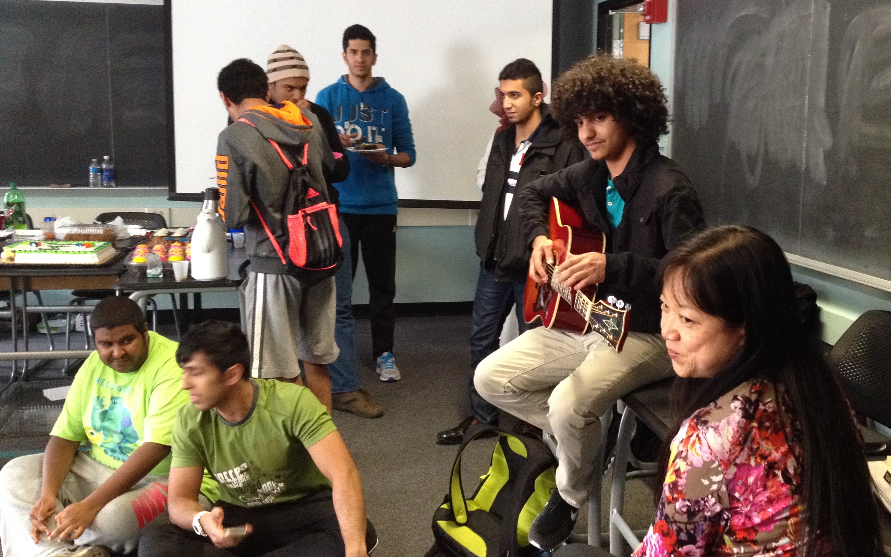
- Know each of your instructors’ requirements and procedures. Most of these are explained in the course syllabus you receive early in the semester.

- Always be prepared for class. Review the work you did the previous class session. Complete any homework or other assignments due that day. Remember that it’s your responsibility to be aware of the deadlines and due dates — IECP instructors and later, university instructors, may not remind you of them. It’s also your responsibility to be aware of any assignments or homework that you may not have turned in — instructors may not remind you of those either.

- Participate in class. Here are some tips:
- Volunteer when you have something to say. Don’t always wait to provide an answer or comment until you are called on by the instructor.
- It’s also not necessary to wait until you are sure your response or comment is 100% correct. Participating in the American classroom means taking the chance that you may be wrong. Students can learn as much from incorrect responses as they do from correct ones.
- IECP instructors use some group work in their classes. It’s your responsibility to speak up and contribute to the work of your group. Here are some helpful group work phrases to use:
  - So, what does the teacher want us to do?
  - What do you think we should do?
  - We should start by doing this…
  - Let’s decide how to share the tasks.
- Listen carefully to your instructor and to your fellow students.
- Ask for clarification from your instructor when you need it. Simply saying, “I don’t understand” is not always helpful. Give your instructor as much information as you can about your difficulty, for example:
  - “I don’t understand why this sentence says ‘a post office’ and that one says ‘the post office.’”
  - “Could you repeat that? I don’t think I understand it completely.”
  - “What does that word mean? I understand everything except for that word.”
- Good participation means speaking regularly but not too much so that others feel they cannot participate. Here are some helpful phrases to use when you want to participate:
  - I think the answer should be….
  - I agree with my classmate, but…
  - I’d like to share my opinion. I think…
- Come to class on time. Arriving late on a regular basis can easily be seen as disrespectful to your instructor and fellow classmates. If you must be late:
  - tell your instructor in advance, if possible;
  - come into class quietly; for example, don’t knock before entering;
  - sit in the empty seat closest to the door;
  - catch up with what the class is doing without disrupting the instructor or your classmates.
- Attend each of your IECP classes. If you must miss a class, tell your instructor in advance, if possible. You are responsible for contacting your instructor or classmates to find out about what occurred in class and about any assignments you may have missed. You are also responsible for completing any missed assignments and for arranging with your instructor to make up any missed quizzes or tests. Missing a class actually means additional responsibility for you, not less!
- Check regularly with your instructors to ask how they think you are doing as their student. What are you doing well? What could you be doing better? Share your ideas about these questions with your instructors, also.
- Always do your own work. Do not copy and paste from the internet. It is O.K. to help each other, but actually doing the work of another or having someone else do yours is considered cheating in American culture. (see p. 22, Academic Honesty)

Penn State Computing

PSU EMAIL
Check your PSU email DAILY
Email is considered official university communication, and you are responsible for checking your PSU email account every day. You will get important messages from your instructors, the IECP Office (iecp@psu.edu), the Student Center (iecp-itc@psu.edu), and DISSA (DISSA-Advisor@psu.edu).

Canvas
Your instructors use course management software for communication, assignments, homework and so forth. At Penn State, the main course management software is Canvas. You should check Canvas every day, especially if you are absent!

CAMPUS COMPUTER LABS
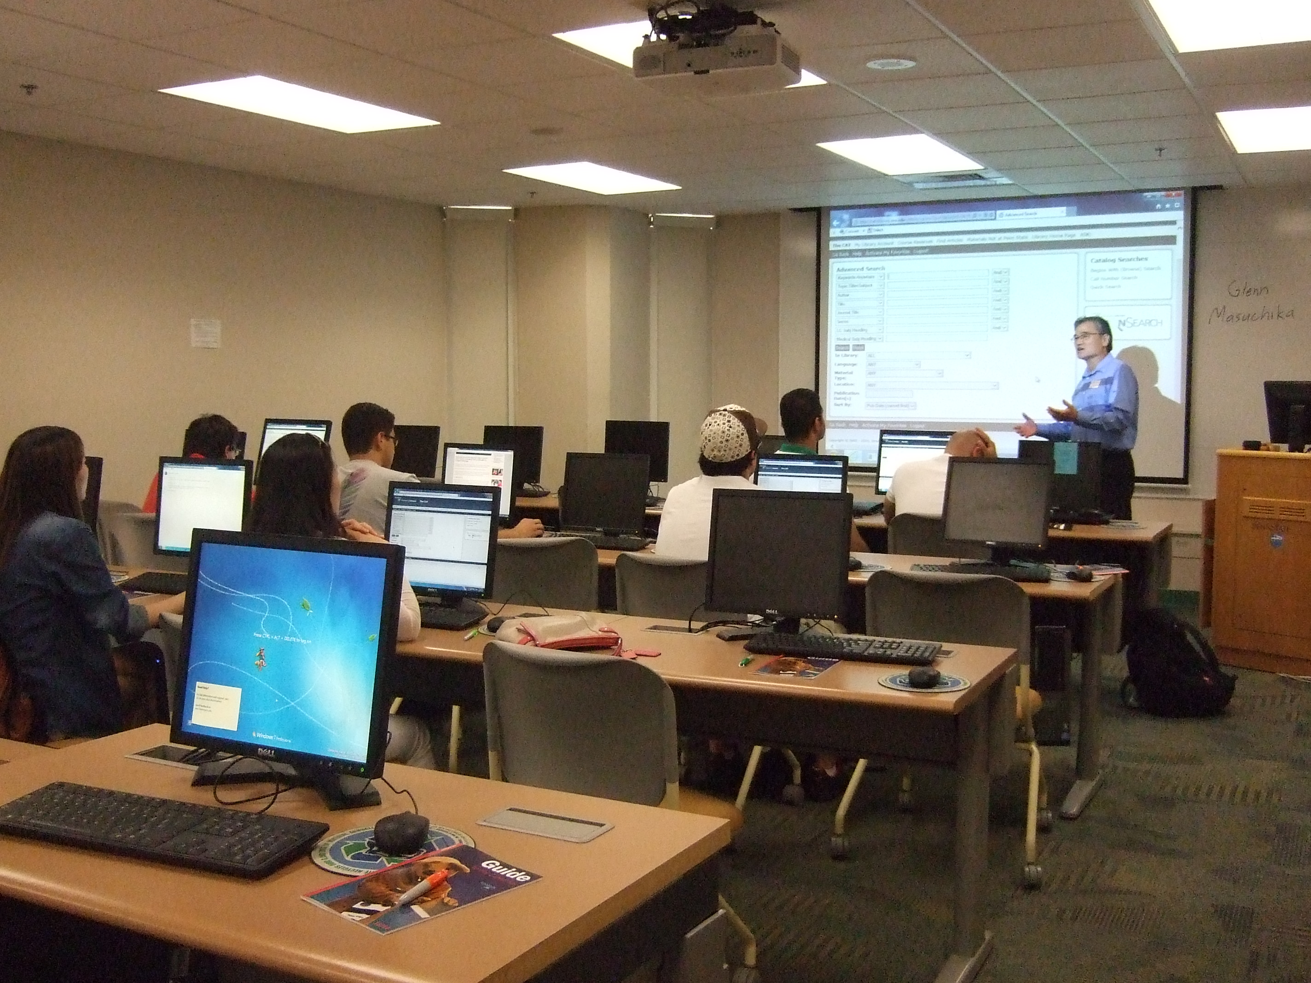
- IECP students can use any computer lab on campus (visit http://clc.its.psu.edu/labs/locations for a list of labs).

- Most IECP students use the lab in Boucke 103 or Wagner 118.

PRINTING
- You can use your LionCash+ to pre-pay for printing. Visit http://clc.its.psu.edu/printing/pricing to add printing to your PSU ID+ card.
- You may be required by your IECP instructors to type and print homework assignments.

IECP Student Center
The Student Center normally offers drop-in tutoring, scheduled tutoring individual and small group appointments, and several workshops each semester. All IECP students are eligible for Student Center services, which are provided for free. Because of Covid, the Student Center is closed for in-person hours, but will offer regular biweekly tutoring starting in mid-September. However, if you would like additional assistance with any of your courses, please let your instructor know and we will make arrangements to provide tutoring or other assistance.

Student Center Mission Statement
The Student Center provides assistance to IECP students in mastering different aspects of English and standardized test preparation. Our focus is on supporting long-term improvement in students' academic English proficiency.

Student Center Services
Student Center offers the following types of tutoring services:
- One-on-one tutoring
- Small-group (2-5 persons) tutoring
- Large-group (20 persons) workshops
- Drop-in tutoring
- You can schedule tutoring sessions with different tutors depending on the skill
- You can be matched with one tutor and have regular weekly sessions
- You can form a group with other IECP students and work together with a tutor on some aspect of English.

Fall 2021:
Student Center Hours: Starts mid-September, TBD
Student Center Coordinator: TBD

MONDAY | TUESDAY | WEDNESDAY | THURSDAY | FRIDAY
TBD | TBD | TBD | TBD | TBD

http://iecp.psu.edu/about/iecp-tutoring-center

Working with our team of tutors, students get help in a variety of English language skills such as reading, oral communication, writing, grammar, pronunciation, conversation, spelling and American idioms. Additionally, students receive assistance with TOEFL test preparation.

Student Center tutors also provide help with test preparation. The center organizes a series of large-group and small-group workshops each semester in addition to custom workshops designed by Student Center tutors. Workshops that have been offered include topics such as “How to Talk on the Phone, in a Bank or a Restaurant”, “Building Up Your Vocabulary,” “Spelling Workshops”, “Articles in English,” “American English Pronunciation,” and “Simple or Perfect? Making Sense of English Tenses.”

Student Center Tutors
The Student Center has a team of experienced and enthusiastic tutors including IECP instructors (teaching assistants) and volunteer tutors (masters and undergraduate students majoring in ESL teaching). All of our volunteer tutors have prior experience teaching English and working with international students. The Student Center also collaborates with IECP faculty consultants to provide appropriate and relevant tutoring for IECP students.

IECP Certification

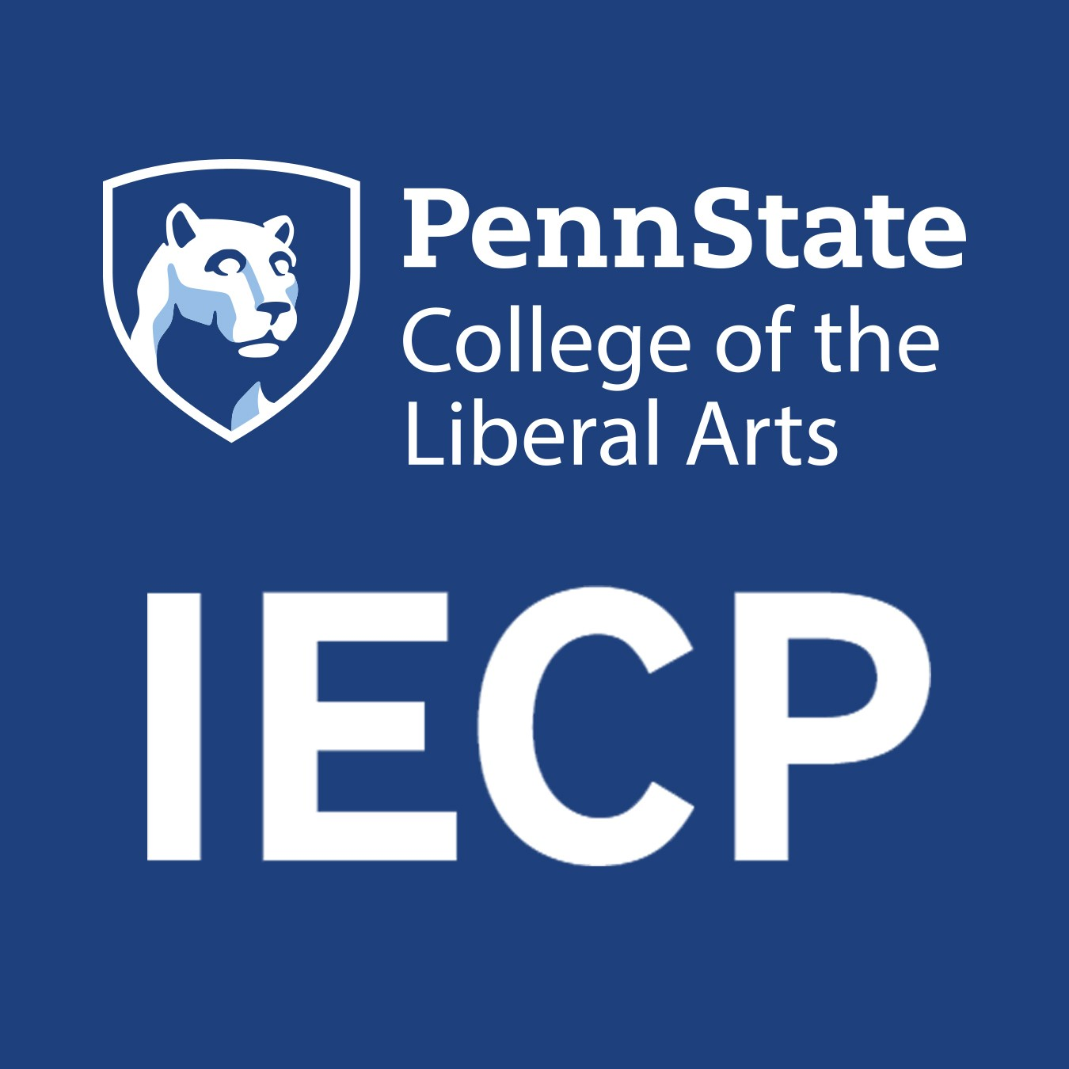
What is Certification?
International students seeking admission to Penn State must meet an English proficiency requirement. Refer to International Requirements: Penn State English Language Proficiency for undergraduate admission. Refer to departmental websites and graduate admissions procedures for your specific graduate program for requirements. Graduate applications are processed by individual graduate departments. The PSU Graduate School accepts IECP Certification, but specific graduate programs have different requirements.

One way to meet the English Language Proficiency requirement is to receive the required TOEFL or IELTS score. Another way is to receive IECP Certification. IECP Certification can be issued for meeting the English Language Proficiency Requirement for undergraduate or graduate admission.

IECP certification is an official statement saying that the program believes the student has the English language proficiency and positive student behaviors necessary for undergraduate or graduate study at Penn State. In addition to simply evaluating English proficiency, as the TOEFL does, we also take into consideration the individual’s academic standing as a student in our program.

Certification is never automatic. IECP Certification decisions are based on IECP grades and a sustained record of performance of meeting IECP Student Responsibilities (see the IECP Student Handbook). Please visit our webpage dedicated to certification at: http://iecp.la.psu.edu/current-students/iecp-certification

Certification application procedures
Students who wish to apply for certification MUST notify the program Director, Dr. Jason Litzenberg (jjl53@psu.edu) as soon as possible and no later than 4 weeks prior to the end of the semester.
To obtain Certification, students must successfully pass a full semester of all Level 140 classes (Academic Interactions 140, Academic Literacies 140, and grammars) as well as an upper-level elective. If a student does not pass any one of these classes, Certification is not provided.

Certification is based on the following:
- IECP grades in all courses
- Observance of IECP student responsibilities

Pathways to Penn State (Dual-Enrollment)
IECP students who have successfully completed one of their 140-level courses (either Academic Interactions 140 or Academic Literacies 140) are eligible for the Pathways to Penn State option. Pathways to Penn State allows students to take IECP courses as well as Penn State courses. Students may only be dual-enrolled for 1 semester.
- The Pathways to Penn State, or Dual-Enrollment option, is not the same as IECP Certification.
- For IECP Certification, students must successfully pass all IECP classes during the semester (including electives).
- Penn State classes completed while in the IECP are not for credit. Credit may be applied retroactively through a student’s department.
- Undergraduate students should plan to take two (2) Penn State courses; graduate students should plan to take one (1) Penn State course.
- While dual-enrolled, the IECP maintains a student’s I-20, so it is imperative that students attend all IECP classes and complete coursework as expected. Dual-enrolled students may be dismissed from the IECP and have their I-20 cancelled exactly the same as other IECP students!

Pathways to Penn State Procedures
STEP 1: Meet with the IECP Director
Before the meeting, the student should search for courses to take at Penn State:
https://public.lionpath.psu.edu/psp/CSPRD/EMPLOYEE/HRMS/h/?tab=DEFAULT
- Choose courses that are in the 0xx, 1xx, or 2xx level
- Make sure the courses do not have prerequisites. You cannot take courses with prerequisites.
- The IECP recommends that you choose courses in a subject that you already know or a course that meets the General Education, or “Gen Ed”, requirements (see http://handbook.psu.edu/content/general-education)
- Prior to the meeting, email the Director (jjl53@psu.edu) the list of courses you are interested in taking. You can choose 4-5 courses, and then we can pick two (2).
STEP 2: After meeting the IECP Director, complete the following:
- Sponsored students need permission from their sponsor and must deliver two forms to the UOGP Sponsored Student Office.
  - Sponsor Release Form
  - Sponsor Student Information Form
  - You may be charged the $500 Sponsored Student by Penn State.
  - If you need the IECP to contact your sponsor, complete a Letter Request Form in the IECP office.
- Apply to the Registrar’s office using the Non-Degree Student application https://www.registrar.psu.edu/student_forms/nondegree_form.cfm
You want to complete this application as soon as possible!
- Please note that after choosing Penn State classes, you must work with the University Registrar and UOGP to ensure that you are registered and enrolled in these classes. The IECP cannot enroll you in these classes!

IECP Policies

Complaints
Sometimes IECP courses can be difficult to adjust to.
- If you have a concern with a class, you should first contact the instructor. It is important for instructors to know if you have concerns because they can best address any problems you have with the class.

- If you have complaints about any other aspect of the IECP, please let us know.
You can contact your instructor or an IECP Administrator.

Appeals
An Appeals Committee reviews student appeals that have been made related to
- Final grades
- Dismissal for exceeding the attendance limit
- Other issues that may cause program termination (dismissal)

To submit an appeal, please go to this link on the IECP website and follow the instructions. http://iecp.psu.edu/current-students/iecp-appeal-form-for-students

Note: Final grade appeals must be submitted by the Wednesday after final grades are available to the student. All appeals are processed within 48 hours of student submission.

Probation, Academic Success Plan and Dismissal
Probation
A student who exceeds the attendance warning status, who is not receiving passing grades in their courses, or whose teacher places them on probation for behavioral reasons, must meet with Jason Litzenberg, the Program Director and Student Advisor. At this meeting the Student Advisor and student discuss strategies to improve attendance and/or discuss behavioral issues.

In rare situations a teacher or the Student Advisor may place a student directly on the Academic Success Plan, bypassing probation. These are instances of rather extreme behavioral concerns.

Academic Success Plan
There are three ways a student can be placed on the Academic Success Plan:
- The student has been put on probation twice for the same behavioral issues in the same semester;
- The student fails to pass a class or classes and must retake a class or classes the following semester;
- A student reaches “Dismissal Warning Status” for attendance reasons.
A student who is on the Academic Success Plan must meet with the Student Advisor at least once during the semester he or she is on the Academic Success Plan.

Dismissal from the IECP
A student may be dismissed from the program if he or she is placed on the Academic Success Plan twice for the same reasons (behavior concerns, not passing a course or courses, exceeding the “Dismissal Warning Status” twice).

In situations where a student’s behavior is extremely detrimental to him or herself and/or the program, the student may bypass probation and the Academic Success Plan, and be dismissed from the IECP.

Removal from Academic Success Plan
There are three ways to be removed from the Academic Success Plan
- The student passes the course(s) that were the reason for placing the student on the Academic Success Plan in the first place;
- The student goes through an entire semester without being placed on probation;
- The student goes through a full semester without going on “Dismissal Warning Status.”

Withdrawing from the IECP
Students who are unable to complete a semester due to extraordinary circumstances should withdraw from their courses; they do not receive grades for that semester. Students need to meet with an IECP Administrator and notify the IECP in writing of their intent to withdraw. (See Attendance Policy on p. 6 and Refund Policy below).

IECP Refund Policy
If a student withdraws from the program, tuition refunds are made according to the Penn State Tuition Adjustment Schedule. (see http://www.bursar.psu.edu/adjustments.cfm for more information).

Beginning on the first day of classes, students who drop below full-time or drop below their originally registered credit level may be assessed a tuition penalty. The tuition adjustment is determined by the effective date of the drop and is made according to Penn State's Tuition Adjustment Schedule.

- Courses that last 10 weeks or more:
1st week: 80%
2nd-5th week: decreases by 20% each week

Notification of withdrawal must be made in writing to the IECP Office. The date the written notification is received by the IECP determines which part of the schedule above applies. If a student is dismissed from the program, no tuition is refunded.
Students who provide a valid financial guarantee letter before Week 5 of the semester are refunded their tuition payments. The IECP application fee is non-refundable.

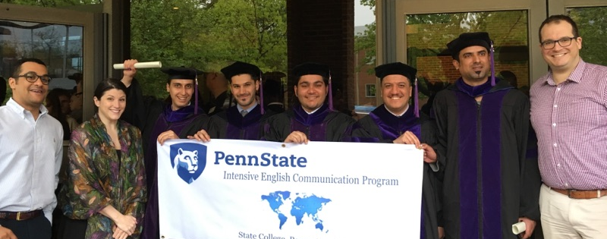

Part-time Students
Most students in the IECP are full-time students. Part-time students may be accepted to study in the IECP on a space-available basis. Part-time students who apply after the application deadline (see http://iecp.la.psu.edu/dates-and-costs for deadlines) are notified of their eligibility to participate in orientation one week before classes begin. Application fees are non-refundable.

Textbooks
Before the first day of class, you can buy your textbooks at the Penn State Bookstore in the Hetzel Union Building (HUB), located across the street from the Boucke building. The IECP recommends purchasing books at the Penn State Bookstore. If you choose to buy required textbooks elsewhere, you are still responsible for completing all assignments on time. You should ask your teachers before purchasing used textbooks. Students should have their textbooks by the second week of the semester. Each student needs his/her own textbook; you should NOT share one textbook with a class mate. Save your receipts for all book purchases and do not write inside your books until you know you will not change classes. Students who are approved for level changes may need to return books and buy other books for their new classes early in the semester.

Making Copies
Students can make copies for class projects, presentations, etc. at the copy center located on the bottom floor of the HUB (Hetzel Union Building), located directly across from the Boucke building. NOTE: The IECP copier is not available for student use.

Sending Faxes
You are allowed to receive and send official sponsor documentation using the IECP fax machine. All personal faxes must be sent elsewhere.

Letters of Recommendation
IECP students may need to ask for letters of recommendation. These are often for university admission or for employment. In asking for letters of recommendation, from IECP instructors or from others, these guidelines should be used:
- Always give instructors or others at least two weeks to finish the letter.
- Give the instructor or others complete information for where to send the letter.
- Tell the instructor or others the specific program or position you are applying for.
- Ask the instructor or others if they would like you to schedule an appointment with them to talk about the specifics of the recommendation you need.

IECP Students Working
Permission to work must be obtained from the Directorate of International Student & Scholar Advising (DISSA) after successful completion of one semester in the IECP and after discussion with an IECP Administrator. Students may only work on campus 20 hours per week.

Continuing after program completion
Students who have completed Level 140 and who choose to remain in the IECP, may, with an IECP Administrator’s permission, repeat two Level 140 courses for up to one semester.

Students may also repeat one 140 course and take no more than two non-degree courses at Penn State (see the section on Pathways to Penn State).

Traveling in the U.S.
It is safer to travel with someone and it is a good idea to carry your important immigration documents with you including your passport, your I-20, and your I-94 card.

Advising

IECP Advising
Your IECP instructors or the IECP staff should be able to answer any questions that you have about your IECP classes. As well, you are always welcome to make an appointment to speak with an IECP Administrator. The IECP Office is open from 8:00 a.m. to 5:00 p.m. Monday through Friday.

For specific issues related to your attendance, probation, the Academic Success Plan, and program dismissal, please visit Jason Litzenberg, the Program Director and Student Advisor.

To speak with an IECP administrator for advising, please check their office hours posted on the bulletin board of the IECP Offices

Penn State Admissions Advising
If you need help with applying to undergraduate or graduate programs, the IECP Office Staff arrange seminars on application processes common among American universities and offer individual appointment counseling by request. Seminars are announced by the IECP on the Semester Events Calendar.

Immigration Advising
Any questions about your visa, your I-20 or DS-2019, your immigration status, or your SEVIS record should be answered only by:
- DISSA (Directorate of International Students & Scholar Advising), located on the 4th floor of the Boucke building. https://global.psu.edu/info/internationals-psu/students/contact-us

Please see your Penn State Global Handbook for IECP Students for information on extending your I-20 or DS-2019, transferring to another university, requesting work authorization or travel signatures for traveling outside the U.S.

You can meet with a DISSA Advisor during their walk-in times Mondays, Wednesdays and Fridays from 1:30-4:30 p.m. or Tuesdays and Thursdays from 8:30-11:30 a.m. Many requests need to be made online through iStart at http://istart.gp.psu.edu

The DISSA advisor for the IECP is Megan Layng (mzl141@psu.edu). Megan should be your first point-of-contact for questions related to visa matters.

Life at Penn State

IECP Activities
The IECP department offers trips and events for IECP students throughout the semester. The IECP also hires Transition Partners, current PSU students, who help introduce IECP students to life at Penn State and interesting things to do in State College. If you have suggestions for activities, please contact iecp@psu.edu.

Due to the Covid pandemic, the IECP is not currently offering extra-curricular activities. We are as disappointed as you and look forward to a return to normal activities!

PSU Student organizations
There are over 1,000 student organizations on campus at Penn State. For more information on how to get involved, visit http://studentaffairs.psu.edu/hub/studentorgs/, http://studentaffairs.psu.edu/hub/studentorgs/orgdirectory/, or email studentorg@psu.edu.

The following is just a small sample of the student organization offered at Penn State:
- Asian Undergraduate Student Association
- Chinese Students and Scholars Association
- Chinese Undergraduate Student Association
- Emirates Student Union
- English Conversation Club
- International Scientists and Engineers Association (ISEA)
- Japanese Friendship Association
- Korean Student Association
- Kuwaiti Students Association
- LGBTA Student Coalition
- Omani Student Association
- Saudi Arabian Student Association
- Soccer
- Taiwanese Student Association
- Video Game Club
- Yoga

Health Insurance & Medical Care

Health Insurance
ALL international students are required to have health insurance for themselves, as well as for their spouses and children (dependents). Please remember that if you are an IECP student, you must either buy insurance from them or obtain a waiver from the Student Health Insurance Office. Students with insurance from outside PSU (sponsored students) must complete the online form https://www.aetnastudenthealth.com/.
NOTE: Paper forms are no longer available except for dependents. If you have dependents (husband, wife, children), you must fill out a paper waiver available in room 302 in the Health Center.
Waivers must be renewed at the beginning of the semester. An accepted waiver applies to the entire academic year during which it is filed.
If you do not buy the insurance or obtain a waiver from the Student Insurance Office by the enrollment deadline, you will have to pay a $50.00 late fee. After the first late payment, you will have to pay a $100.00 late fee every time the deadline is missed. For more detailed insurance information, please refer to the Student Health Insurance Office web site: http://studentaffairs.psu.edu/health/services/insurance/

Health Care
All IECP students can use the Penn State University Health Services.
University Health Services Hours

phone: (814-865-7467) or online (http://studentaffairs.psu.edu/health/myUHS/)

Days: Time:
Mon. Tues. Thurs. Fri. 8:00 a.m. to 5:00 p.m.
Wednesday 9:00 a.m. to 5:00 p.m.
Saturday 11:00 a.m. to 3:00 p.m.

See the University Health Services brochure for information about fees and services.
In general, students should not miss class to visit the doctor. When scheduling appointments, try to request appointments at times when you are not in class.
If University Health Services is not opened at a time when you need to see a doctor, you may go to any urgent care center in the State College area. Urgent care centers are staffed with doctors, nurses, and other medical professionals and are often cheaper than going to the hospital emergency room. To find one that is closest to you, do a search for “urgent care centers.”

Serious Health Emergencies
Dial 911 or go directly to the Mount Nittany Medical Center Emergency Room.
Note: Ambulance service in the U.S. is expensive, costing hundreds of dollars. Check your insurance to see what kind of ambulance coverage you have.

IECP students risk failing classes or being dismissed from the program by not complying with IECP Student Responsibilities and Penn State Principles.

